We will use the corpus:
D1 = "I love my India."
D2 = "I love my country."
D3 = "India is my country."
1. Step 1 — Tokenization and lowercase
Your bow_from_scratch() uses:
doc.split()
and then:
word.lower()
So we get:
Document | Words
D1 | i, love, my, india.
D2 | i, love, my, country.
D3 | india, is, my, country.
⚠️ Important: Because your code only uses .split(), punctuation is not removed. Therefore "India." and "India" are treated as different words.
For a classroom demonstration, let's first calculate exactly according to your code.

2. Vocabulary
All unique lowercase words are:
i
love
my
india.
country.
india
is
After sorting:
['country.', 'i', 'india', 'india.', 'is', 'love', 'my']
So we assign indexes:
Index | Word
0 | country.
1 | i
2 | india
3 | india.
4 | is
5 | love
6 | my

3. Bag-of-Words calculation
Now count how many times each word appears in each document.
D1: "I love my India."
Words:
i
love
my
india.
Therefore:
Word | Count
country. | 0
i | 1
india | 0
india. | 1
is | 0
love | 1
my | 1
So:

D2: "I love my country."
Words:
i
love
my
country.
Therefore:

D3: "India is my country."
Words:
india
is
my
country.
Therefore:

4. Final BoW Matrix
Putting everything together:
Document | country. | i | india | india. | is | love | my
D1 | 0 | 1 | 0 | 1 | 0 | 1 | 1
D2 | 1 | 1 | 0 | 0 | 0 | 1 | 1
D3 | 1 | 0 | 1 | 0 | 1 | 0 | 1
Therefore:
[[0 1 0 1 0 1 1]
[1 1 0 0 0 1 1]
[1 0 1 0 1 0 1]]

5. Now calculate TF-IDF
We have:
because there are 3 documents.
The formula we'll use is:
and:
where DF = number of documents containing the word.

6. Calculate Document Frequency (DF)
Let's count how many documents contain each word.
Word | D1 | D2 | D3 | DF
country. | 0 | 1 | 1 | 2
i | 1 | 1 | 0 | 2
india | 0 | 0 | 1 | 1
india. | 1 | 0 | 0 | 1
is | 0 | 0 | 1 | 1
love | 1 | 1 | 0 | 2
my | 1 | 1 | 1 | 3
Notice:
"my" occurs in every document.
Therefore its DF is 3.

7. Calculate IDF
We have:
We'll use the natural logarithm (ln).
For country.
DF = 2

For i
DF = 2

For india
DF = 1

For india.
DF = 1

For is
DF = 1

For love
DF = 2

For my
DF = 3
This is an important observation:
"my" appears in every document, so its IDF is 0.
Therefore, TF-IDF considers "my" unimportant for distinguishing these documents.

8. IDF table
Word | DF | IDF
country. | 2 | 0.4055
i | 2 | 0.4055
india | 1 | 1.0986
india. | 1 | 1.0986
is | 1 | 1.0986
love | 2 | 0.4055
my | 3 | 0

9. Calculate TF for D1
D1 has 4 words:
I love my India.
Each occurs once.
Therefore:
So:
Word | TF
country. | 0
i | 0.25
india | 0
india. | 0.25
is | 0
love | 0.25
my | 0.25

10. Calculate TF-IDF for D1
Formula:
i
india.
love
my
Therefore:

11. D2
D2:
"I love my country."
Again, 4 words.
TF for each occurring word:
Now calculate:
country.
i
love
my
Therefore:

12. D3
D3:
"India is my country."
Four words.
Again:
country.
india
is
my
Therefore:

13. Final TF-IDF Matrix
Document | country. | i | india | india. | is | love | my
D1 | 0 | 0.1014 | 0 | 0.2747 | 0 | 0.1014 | 0
D2 | 0.1014 | 0.1014 | 0 | 0 | 0 | 0.1014 | 0
D3 | 0.1014 | 0 | 0.2747 | 0 | 0.2747 | 0 | 0

⭐ What does this tell us?
Look at the important words:
D1
India. → 0.2747
It has a high score because India. appears in only one document.
D3
India → 0.2747
is → 0.2747
These are relatively important because they occur in only one document.
my
my → 0
Why?
Because "my" appears in all 3 documents.
So it doesn't help distinguish between the documents.

⚠️ One important issue with YOUR code
There is a subtle problem here.
Your code uses:
doc.split()
It does not remove punctuation.
Therefore:
"India."
and:
"India"
are treated as two different words.
That's why our vocabulary contains both:
india
india.
For real NLP preprocessing, you would normally clean punctuation first:
import re

text = re.sub(r'[^\w\s]', '', text)
Then your documents become:
D1 = "I love my India"
D2 = "I love my country"
D3 = "India is my country"
Now the vocabulary becomes much more sensible:
['country', 'i', 'india', 'is', 'love', 'my']
And India in D1 and India in D3 will correctly be recognized as the same word.
For teaching NLP, I strongly recommend showing students both versions: first the raw split() implementation to understand the algorithm, and then the cleaned version to demonstrate why preprocessing matters.
For examination. give me such 4 examples with complete solution
Certainly. Below are 4 examination-style TF-IDF problems, progressing from easy to moderate difficulty. I have given the complete solution, including vocabulary, BoW, TF, DF, IDF, TF-IDF, and final matrix.
Assumption for all questions:
Use natural logarithm (ln) and do not consider punctuation as part of words.

📝 Example 1 — Basic TF-IDF
Question
Consider the following documents:
D1: "I love NLP"
D2: "I love AI"
D3: "NLP is interesting"
Calculate:
- Vocabulary
- Bag-of-Words matrix
- DF and IDF
- TF-IDF matrix

Solution
Step 1: Vocabulary
Unique words:
I, love, NLP, AI, is, interesting
After lowercase and sorting:
Index | Word
0 | ai
1 | i
2 | interesting
3 | is
4 | love
5 | nlp

Step 2: BoW Matrix
Document | ai | i | interesting | is | love | nlp
D1 | 0 | 1 | 0 | 0 | 1 | 1
D2 | 1 | 1 | 0 | 0 | 1 | 0
D3 | 0 | 0 | 1 | 1 | 0 | 1

Step 3: DF
Word | DF
ai | 1
i | 2
interesting | 1
is | 1
love | 2
nlp | 2
There are:
documents.

Step 4: IDF
For DF = 1:
For DF = 2:
Therefore:
Word | DF | IDF
ai | 1 | 1.0986
i | 2 | 0.4055
interesting | 1 | 1.0986
is | 1 | 1.0986
love | 2 | 0.4055
nlp | 2 | 0.4055

Step 5: TF
Every document has 3 words.
Therefore each occurring word has:

Step 6: TF-IDF
For D1:
i
love
nlp
So:
Similarly:
because:
And:
Final TF-IDF Matrix
Document | ai | i | interesting | is | love | nlp
D1 | 0 | 0.1352 | 0 | 0 | 0.1352 | 0.1352
D2 | 0.3662 | 0.1352 | 0 | 0 | 0.1352 | 0
D3 | 0 | 0 | 0.3662 | 0.3662 | 0 | 0.1352

📝 Example 2 — Repeated Words
Question
Consider:
D1: "data data science"
D2: "data science science"
D3: "machine learning"
Calculate the TF-IDF representation.

Solution
Step 1: Vocabulary
Unique words:
data, science, machine, learning
Sorted:
Index | Word
0 | data
1 | learning
2 | machine
3 | science

Step 2: BoW
Document | data | learning | machine | science
D1 | 2 | 0 | 0 | 1
D2 | 1 | 0 | 0 | 2
D3 | 0 | 1 | 1 | 0

Step 3: DF
Word | DF
data | 2
learning | 1
machine | 1
science | 2
Therefore:
For DF = 2:
For DF = 1:
Word | DF | IDF
data | 2 | 0.4055
learning | 1 | 1.0986
machine | 1 | 1.0986
science | 2 | 0.4055

Step 4: TF
D1
D1 has 3 words:
data data science
Therefore:
D2
data science science
D3
machine learning
There are 2 words:

Step 5: TF-IDF
D1
Data:
Science:
Therefore:
D2
Data:
Science:
Therefore:
D3
Machine:
Learning:
Therefore:
Final Answer
Document | data | learning | machine | science
D1 | 0.2703 | 0 | 0 | 0.1352
D2 | 0.1352 | 0 | 0 | 0.2703
D3 | 0 | 0.5493 | 0.5493 | 0
⭐ Exam point: Notice that data gets a higher TF in D1 because it occurs twice.

📝 Example 3 — Common Word in Every Document
Question
Consider:
D1: "AI is powerful"
D2: "AI is useful"
D3: "AI is intelligent"
Calculate the TF-IDF matrix.

Solution
Step 1: Vocabulary
ai, is, powerful, useful, intelligent
Sorted:
Index | Word
0 | ai
1 | intelligent
2 | is
3 | powerful
4 | useful

Step 2: BoW
Document | ai | intelligent | is | powerful | useful
D1 | 1 | 0 | 1 | 1 | 0
D2 | 1 | 0 | 1 | 0 | 1
D3 | 1 | 1 | 1 | 0 | 0

Step 3: DF
Word | DF
ai | 3
intelligent | 1
is | 3
powerful | 1
useful | 1
For ai:
For is:
For words occurring once:
Therefore:
Word | IDF
ai | 0
intelligent | 1.0986
is | 0
powerful | 1.0986
useful | 1.0986

Step 4: TF
Every document contains 3 words.
Therefore:

Step 5: TF-IDF
D1
AI:
is:
powerful:
Therefore:
D2
Only useful gets a non-zero value:
Therefore:
D3
intelligent:
Therefore:
Final Matrix
Document | ai | intelligent | is | powerful | useful
D1 | 0 | 0 | 0 | 0.3662 | 0
D2 | 0 | 0 | 0 | 0 | 0.3662
D3 | 0 | 0.3662 | 0 | 0 | 0
⭐ Important exam concept
This example demonstrates:
If a word occurs in every document, its IDF becomes zero.
Therefore:
This is one of the most important concepts students should understand.

📝 Example 4 — Slightly Difficult / Repeated Words + Different Document Lengths
Question
Consider:
D1: "cat cat dog"
D2: "cat dog mouse mouse"
D3: "dog mouse"
Calculate:
- Vocabulary
- BoW matrix
- TF
- DF
- IDF
- TF-IDF matrix

Solution
Step 1: Vocabulary
Unique words:
cat, dog, mouse
Vocabulary:
Index | Word
0 | cat
1 | dog
2 | mouse

Step 2: BoW
D1
cat cat dog
Therefore:
[2, 1, 0]
D2
cat dog mouse mouse
Therefore:
[1, 1, 2]
D3
dog mouse
Therefore:
[0, 1, 1]
Final BoW:
Document | cat | dog | mouse
D1 | 2 | 1 | 0
D2 | 1 | 1 | 2
D3 | 0 | 1 | 1

Step 3: DF
Now count documents containing each word.
Cat
Appears in:
- D1
- D2
Therefore:
Dog
Appears in:
- D1
- D2
- D3
Therefore:
Mouse
Appears in:
- D2
- D3
Therefore:

Step 4: IDF
There are:
For cat:
For dog:
For mouse:
Word | DF | IDF
cat | 2 | 0.4055
dog | 3 | 0
mouse | 2 | 0.4055

Step 5: TF
This is where the example becomes slightly more interesting.
D1
D1 has 3 words.
cat cat dog
Therefore:
D2
D2 has 4 words.
cat dog mouse mouse
Therefore:
D3
D3 has 2 words.
dog mouse
Therefore:

Step 6: TF-IDF
D1
Cat
Dog
Therefore:

D2
Cat
Dog
Mouse
Therefore:

D3
Dog
Mouse
Therefore:

🎯 Final TF-IDF Matrix
Document | cat | dog | mouse
D1 | 0.2703 | 0 | 0
D2 | 0.1014 | 0 | 0.2027
D3 | 0 | 0 | 0.2027

📌 Four Examples at a Glance
Example | Main concept tested | Difficulty
1. NLP / AI | Basic TF-IDF | ⭐
2. Data / Science | Repeated words | ⭐⭐
3. AI / Intelligent | Word appearing in every document | ⭐⭐
4. Cat / Dog / Mouse | Different document lengths + repeated words | ⭐⭐⭐

🧠 Exam Formula Sheet
Students can memorize these three formulas:
1️⃣ Term Frequency
2️⃣ Inverse Document Frequency
3️⃣ TF-IDF
Remember:
TF → How frequently does the word occur here?
DF → In how many documents does the word occur?
IDF → How rare is the word?
TF-IDF → How important is the word for this document?
High TF + Low DF → High TF-IDF
Word in every document → IDF = 0 → TF-IDF = 0
These four are suitable for an NLP university examination, especially if students are expected to perform the calculations manually.

🧠 Exam Formula Sheet
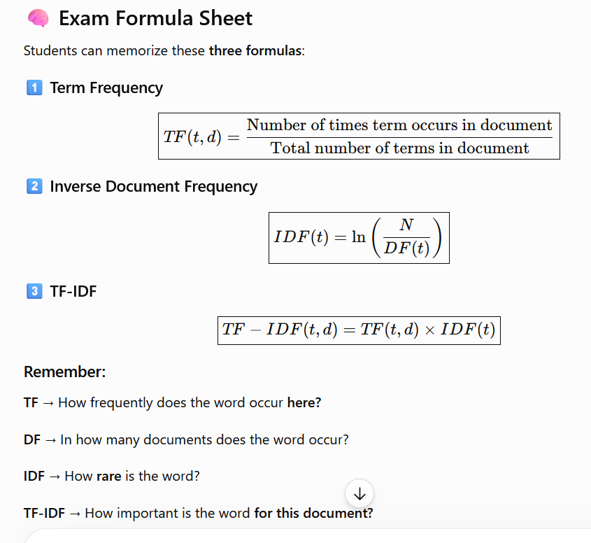
Students can memorize these three formulas:
1️⃣ Term Frequency
2️⃣ Inverse Document Frequency
3️⃣ TF-IDF
Remember:
TF → How frequently does the word occur here?
DF → In how many documents does the word occur?
IDF → How rare is the word?
TF-IDF → How important is the word for this document?
High TF + Low DF → High TF-IDF
Word in every document → IDF = 0 → TF-IDF = 0

